SHRIMATI INDIRA GANDHI COLLEGE TIRUCHIRAPALLI

DEPARTMENT OF PHYSICS

NAAN MUDHALVAN PROJECT REPORT

Project partner: smart internz

Project by: Data literacy with tableau

Class: III B.Sc (physics)

Team ID:NM2023TMID04660

INDIA’S AGRICULTURAL CROP PRODUCTION ANALYSIS

(1997-2021)

INTRODUCTION

OVERVIEW:

This report delves into the captivating realm of india’s agricultural cultivation, providing a comprehensive visual exploration of key aspects and trends in the agricultural sector. Through the visual representations, readers can gain valuable insights into crop production, seasonal variations, regional distribution, and overall production trends. These visualizations enable intuitive analysis, allowing stakeholders to uncover patterns, identify areas of growth or concern, and make data-driven decisions.

PURPOSE:

Agriculture in India is important for the development of the industrial sector and for trading purposes. Agricultural products like tea, coffee, etc. are some of the most edible, and textiles of India contribute to many parts of the total export from the country.

PROBLEM DEFINITION AND DESIGN THINKING

EMPATHY MAP:

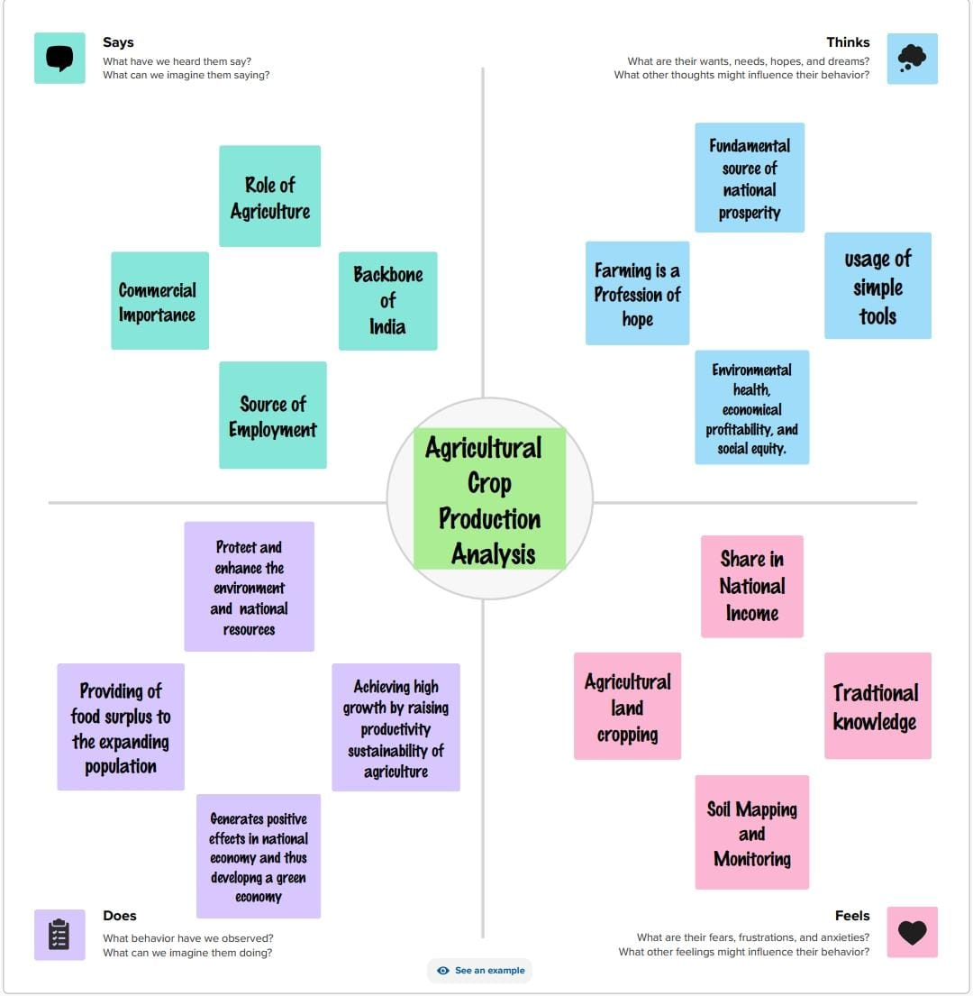

BRAINSTROMING MAP:



RESULT:

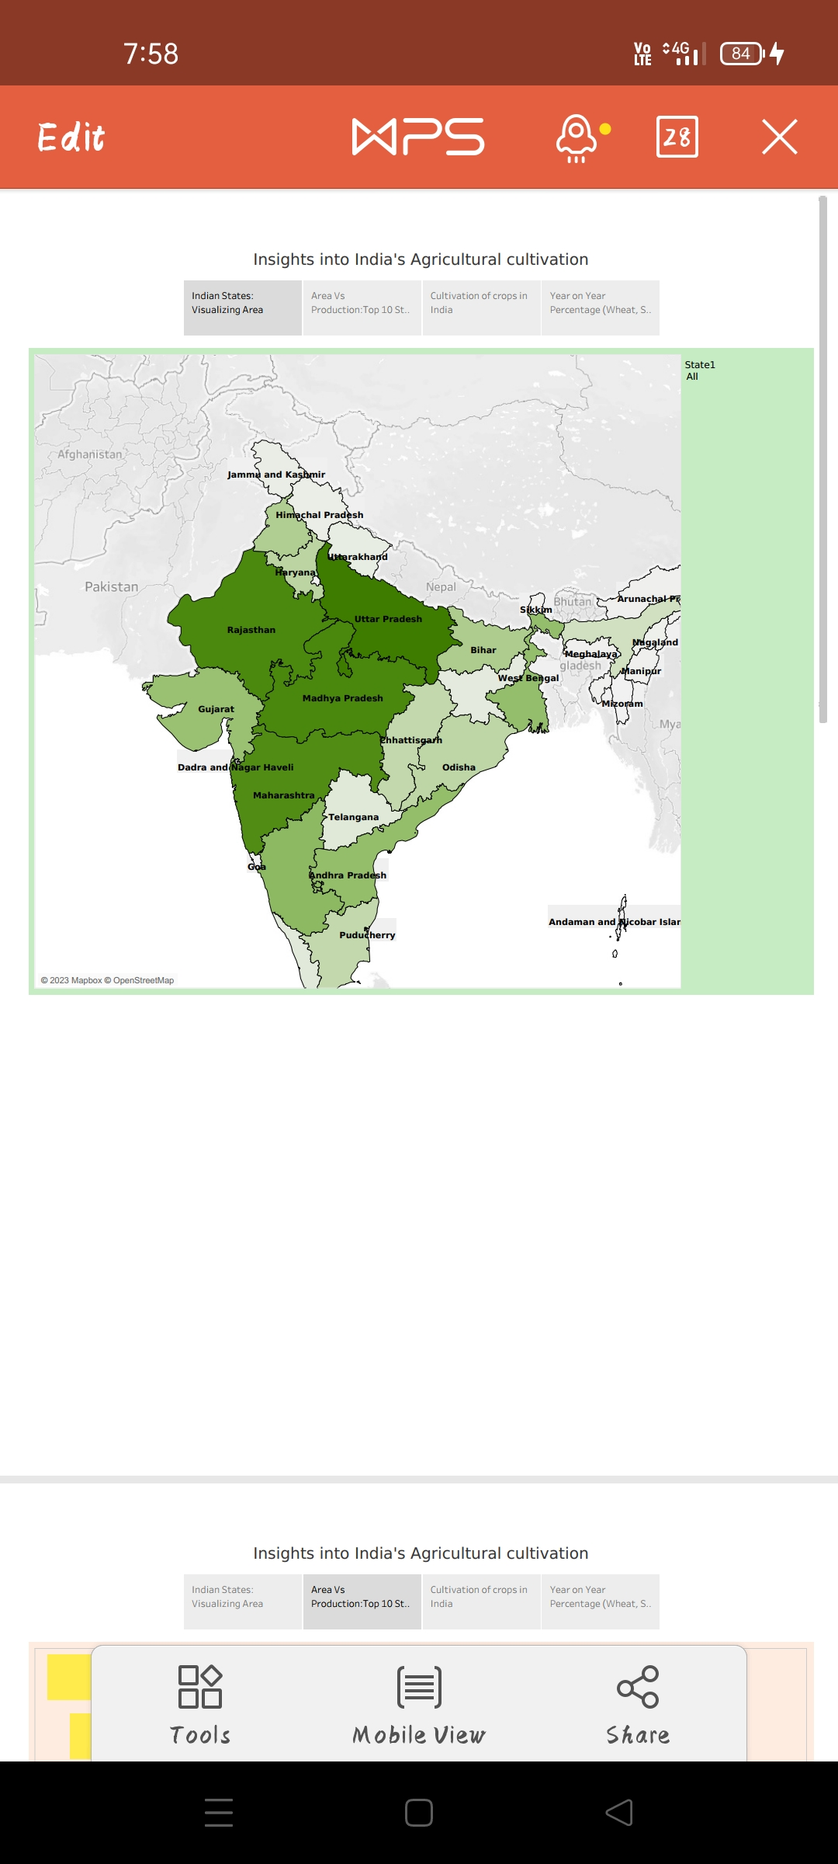

In this project, we conclude that the statewise agricultural land, area vs production, season based cultivation area, and major crops.

ADVANTAGES:

* Agriculture provides employment opportunities to rural agricultural and non-agricultural labourers.
* It plays a significant role in international trade and import and export activities.
* India is the second-most populous country in the world. And to feed such a huge population, there is always a constant need for a supply of food. Therefore, there is a need for agriculture and a need for less dependency on the agriculture sector for the Economy.

DISADVANTAGES:

* Inadequate irrigation facilities and poor management of water resources have led to a great decline in agricultural productivity.
* Over-dependence on unreliable rain and lack of irrigation facilities had led to a decline in agricultural output.

Poverty and illiteracy of the farmers prevent them from making large-scale capital investments and adopting scientific methods of cultivation.

CONCLUTION:

* The Agriculture sector is of vital importance for the region. Agriculture has given so much to society but it has its own pros and cons that we can’t over look.
* It is under going a process of transition to a market economy , with substantial changes in the social, legal, structural, productive and supply set-ups, as in the case with all other sector of the economy.
* India’s Agriculture sector is still very important to the indian economy, although its share of the economy has decreased over the past 50 years.

FUTURE SCOPE:

* Agriculture sector have an enormous scope in India as of the future refrence because agriculture sector is the largest sector with 49% of country's population works in Agriculture sector by occupation.
* India is also a developing country with about 16% of its GDP is contributed by this sector.

APPENDIX:

SOURCE CODE:

https://public.tableau.com/app/profile/meenakshi.h